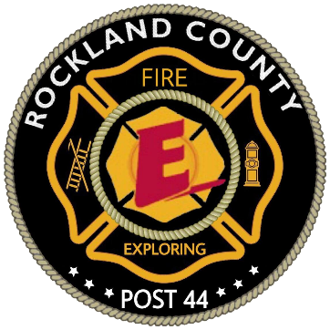
Commonly used fire radio terms in Rockland County (TAC).

“A” (Or 1) Side, “B” (or 2) Side, “C” (or 3) Side, “D” (or 4) side - building side designators. When fighting a structure fire it is necessary to be able to specify a particular side of a building. To make this happen, the "primary" side of the building - usually the one that the chief in command has parked their vehicle - is called the “A” (or 1) Side. While some departments use the A, B, C, D terminology others use the 1,2,3,4 while both are okay to use some believe the number system is better as “C” and “D” sound too similar.
Received – Term used when a message has been received. (It is highly recommended that you use this term after you clearly understand a message sent to you as well as repeat what was said by the sender to prevent miscommunication.)
Urgent - URGENT is used to signal a serious situation that has the potential to either endanger the safety of operating emergency personnel or significantly impact fire ground operations. Some situations that could be considered as an URGENT are Severe change in conditions, Loss of water, does not affect the ability to remove yourself from the area, Possible danger of collapse, Lost and cannot find way out. If Firefighters are unsure of whether the situation dictates an URGENT or MAYDAY situation a MAYDAY should be transmitted.
Mayday – Mayday is an emergency procedure word used in times of crisis such as when stuck/Pinned or when injured severely. Mayday should be used when you or a member of your team requires immediate assistance. (In this case, a F.A.S.T. is most likely to be activated)
FAST (or F.A.S.T., Also known as R.I.T.) - Firefighter assist and search team (also called rapid entry team or rapid intervention team “RIT”) is a team (Generally four or more) of certified firefighters that are solely dedicated to the search and rescue of other firefighters in danger or distress.
Evacuation - Removal of all emergency personnel when the scene is deemed too dangerous for emergency personnel. (Remember! Your life is important too)
Command (IC) – Usually a Chief or if not present a high ranking officer. However, in some cases, it may be the chauffeur (Or driver) if no high ranking personnel are present.
Operations – Operations is a high ranking officer who is the main contact for firefighters during an active emergency. When needed operations will convey important information to command (IC). However, in some cases, there may not be an operations officer but you should still use this call sign as to get in the habit.
PAR (Or P.A.R.) - Personnel accountability report, Used to confirm all team members are present and accounted for.
Fire Radio Signals in Rockland County
(Mainly used on dispatch frequency)

- 10 - Fire (Clear the air)
- 11 - Situation under control; returns radio to normal usage
- 12 - Working fire
- 13 - Refreshments
- 14 - Unit return or returning to quarters
- 15 - Assignment complete
- 16 - Drill
- 17 - False alarm
- 18 - Hazardous materials involved
- 19 - Arson investigator requested
- 20 - Emergency other than a fire
- 21 - Bomb threat
- 100 - Clear the air (announcement only by 44-Control)

Example:
“44-Control to department 27, SIGNAL 12, structure fire, Number 5 Jefferson Drive”
In this example, 44-Control (Dispatch) is notifying “Department 27” of a “Signal 12” (Which is a working fire) “Structure fire” at the address “5 Jefferson Drive”. Signals are terms used to shorten and simplify what the sender would like to convey to the recipient to make communication quick and efficient.

